Muhammad Hassan Khalid
21L-5692
Lab 3

Using Filters to Remove Attributes
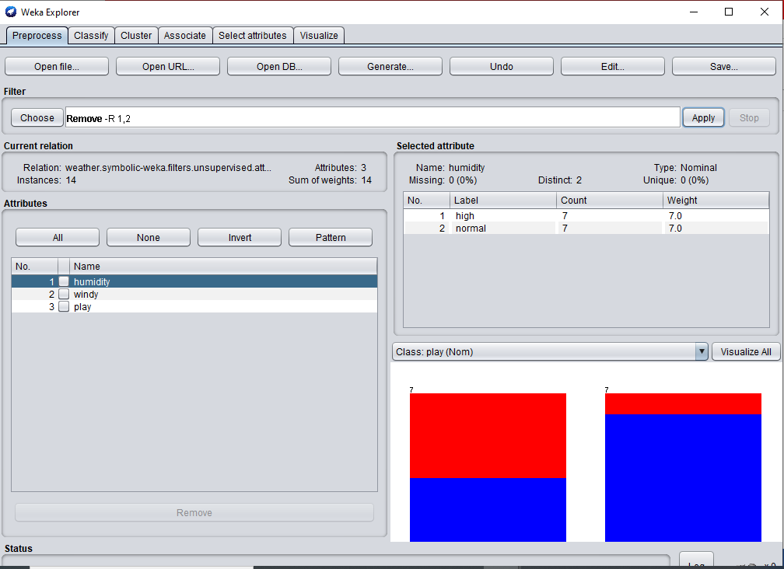

We remove the attributes if the attributes are of no use to us like if in the dataset there is a attribute of playground size it is of no use to us as we want to determine wether a kid wants to play and we should only check the outside temperature further to reduce unnecessary attributes so we can see our data better and visualize in a better way.

Handling missing data

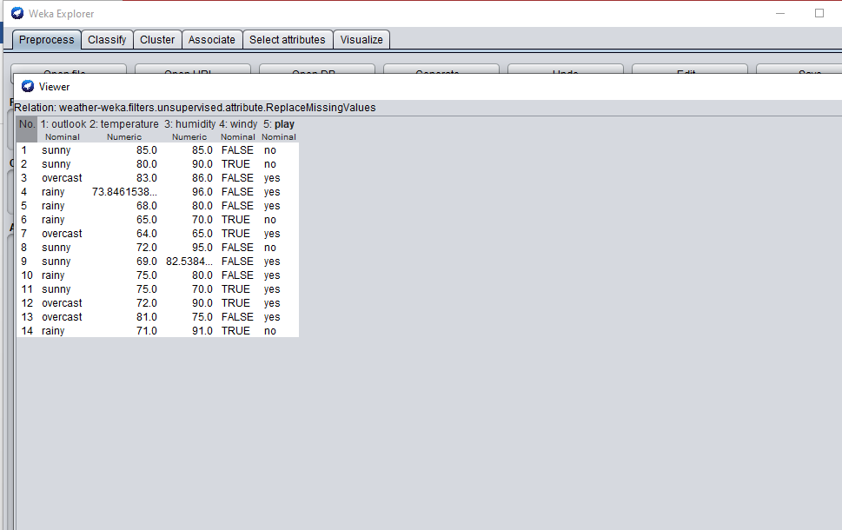

We give arbitrary values so that there are no null values as it can lead to imperfections in learning our model so we add values by ourselves using mean median mode this helps give us better results from our model we can also remove that specific row but it leads to less data so it is better to fill with mean

Using Filters to handle outliers and extreme values

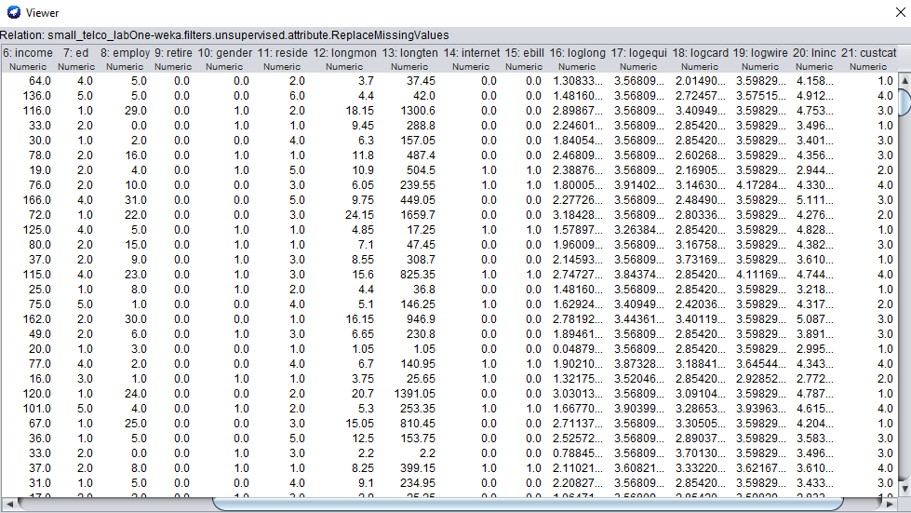

We give arbitrary values so that there are no null values as it can lead to imperfections in learning our model so we add values by ourselves using mean median mode this helps give us better results from our model we can also remove that specific row but it leads to less data so it is better to fill with mean

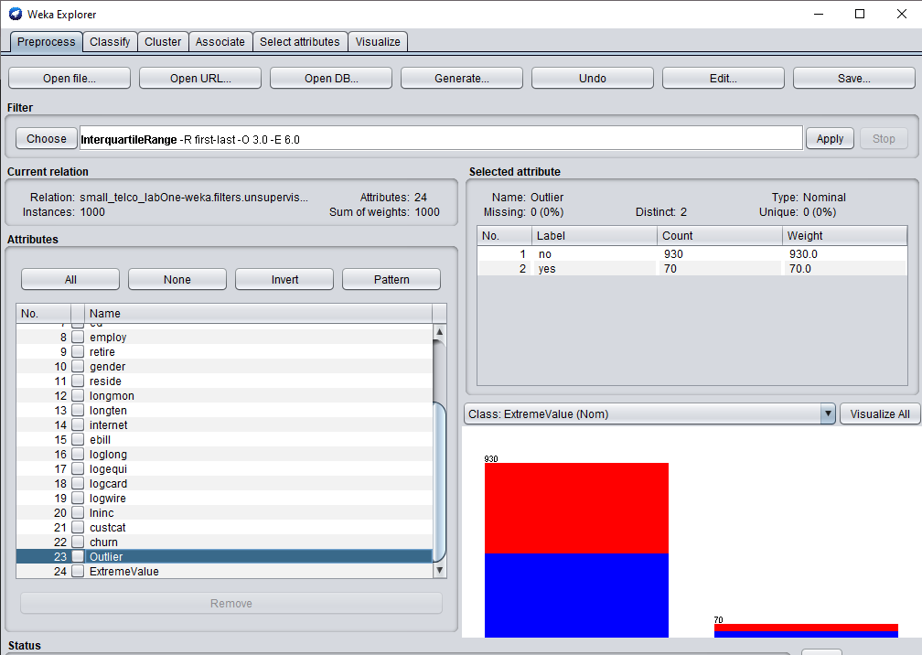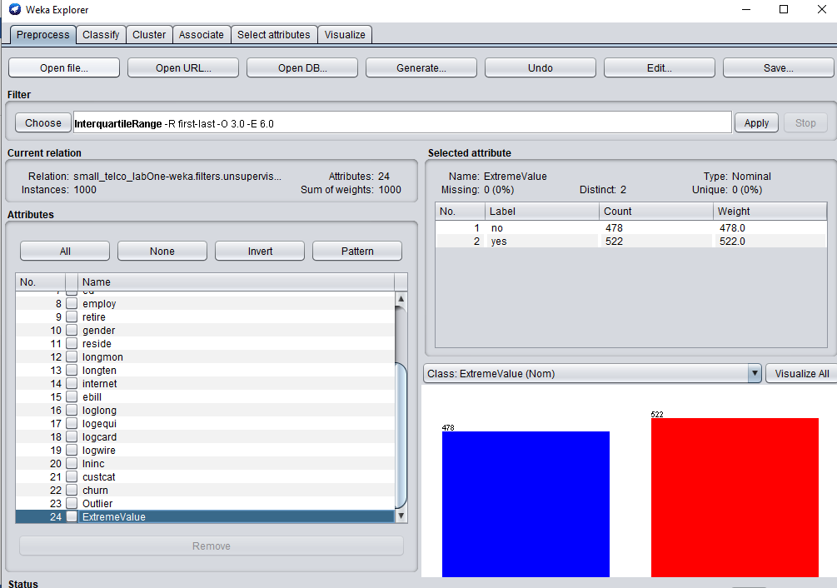

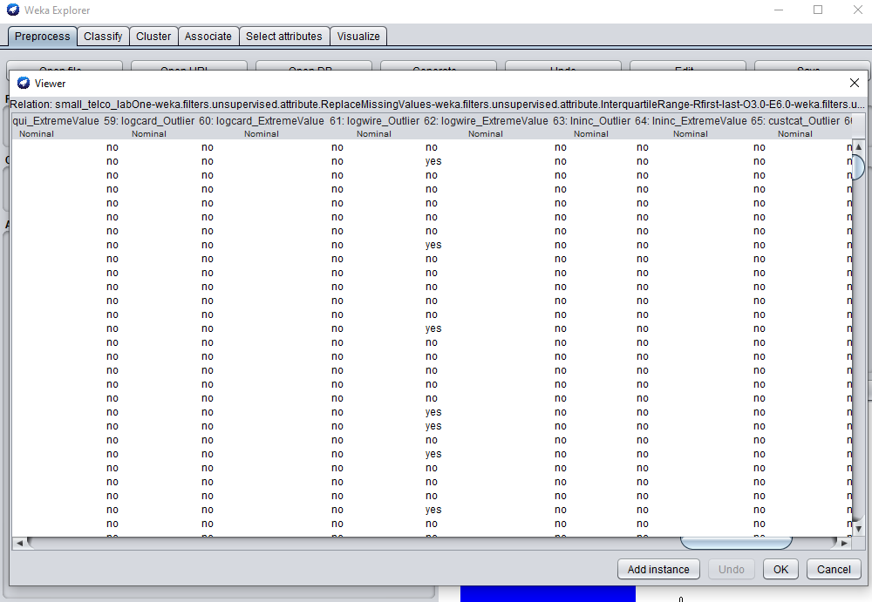

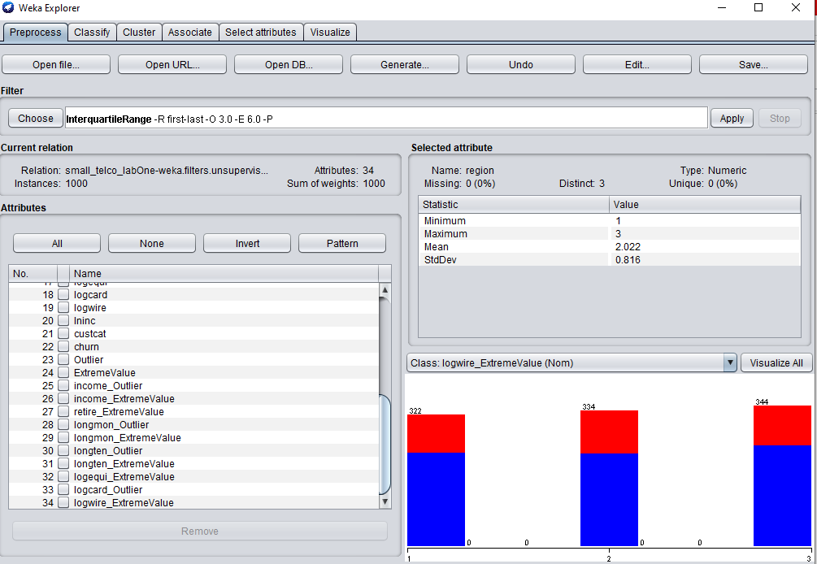

We remove all outliers and extreme values so that our model can correctly predict values as these values cause noise and problem in predicting that’s why we remove them and to remove them first we need to identify them using inter quartile range.

Unsupervised Instance Filter – RemoveWithValues

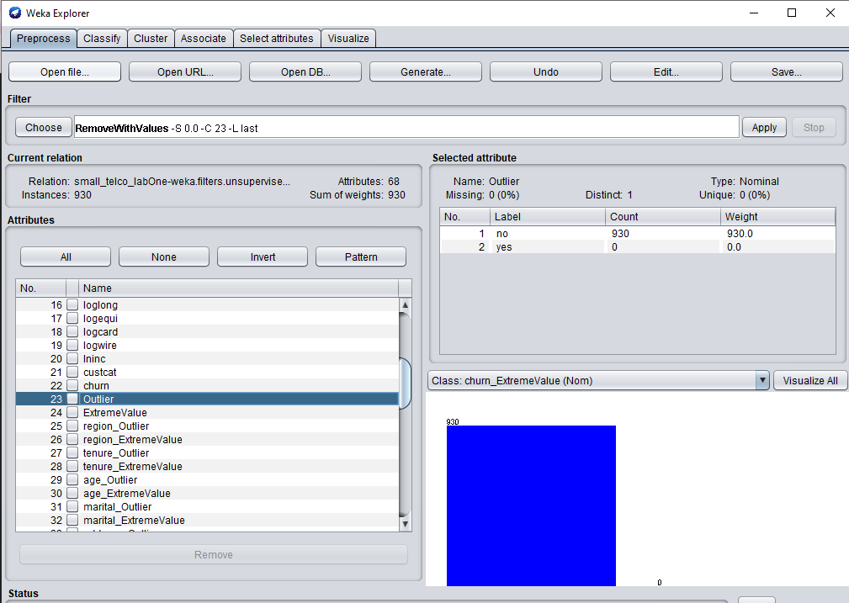

We remove the outliers so that our model can better predict as these outliers cause wrong predictions

Using filters to perform normalization

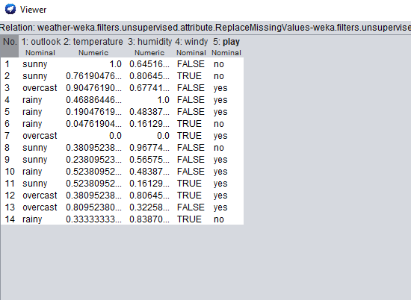

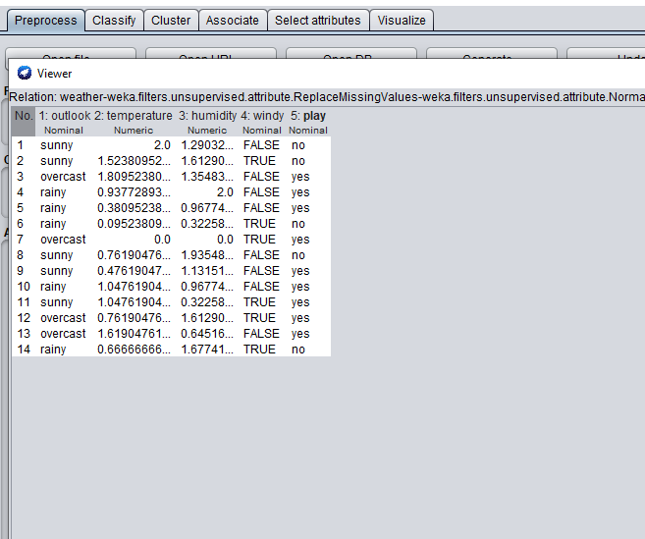

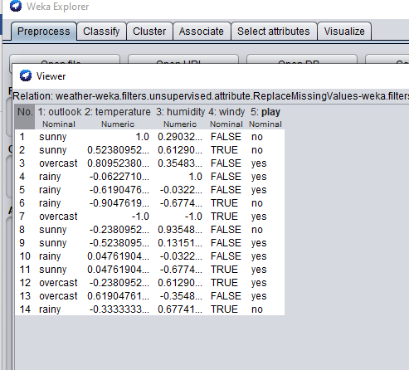

We normalize data to make it consistent and error free. By normalizing data is brought in a similar format so its easier to understand and use. Also because machine learning algorithms tend to perform better, or converge faster, when the different features are on a smaller scale.

